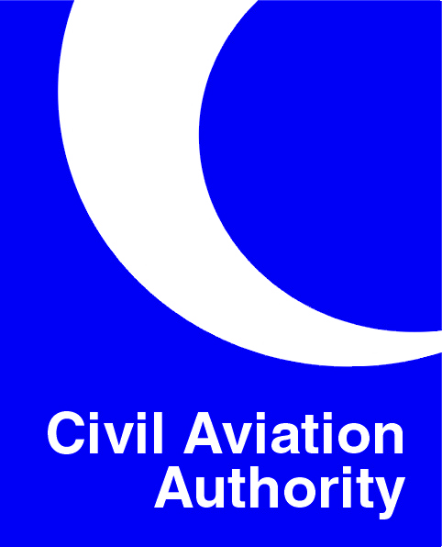

9 December 2009

SINGLE EUROPEAN SKY CAA INFORMATION BULLETIN
The (SES II) regulation amending the four high level SES regulations was published in the Official Journal of the European Union (OJEU) on 14 November. The regulation comes into force on 4 December 2009, although many of its provisions will only be implemented once detailed Implementing Rules (IRs) have been adopted.
The Commission has now begun work on these IRs, with the initial focus on development of the Performance Scheme. A draft Performance Scheme IR was presented to the Single Sky Committee (SSC) on 3-4 December for initial discussion. CAA is engaged with the Commission on developing the IR but has concerns about its proposed scope; in particular on how cost efficiency targets may impact on the provision of terminal services (i.e. Airport ATS), where there is a contestable market for service provision. The Commission has set out an ambitious plan to develop the IR over the next three months in order to seek an SSC opinion on the IR at the next SSC on 23 and 24 March. The Eurocontrol Performance Review Commission are supporting the Commission on this work and are developing proposals for the EU wide targets in the areas of safety, capacity, cost efficiency and the environment, which will underpin the scheme. A revision to the Charging Regulation is expected to be dealt with in the same timescales, but the Commission have yet to issue a draft.

Eurocontrol have published their initial plan to develop an IR on Standardised European Rules of the Air. Formal consultation is expected to begin in February 2010.

The regulation amending the EASA basic regulation to extend the EASA system to the safety regulation of ATM/ANS and Aerodromes was published in the OJEU on 21 November and comes into force on 11 December. Work has now begun to develop EASA’s ATM IRs. The first meetings of three ATM rule drafting groups, dealing with ANSP, competent authority and ATCO licensing requirements took place in November. CAA is taking part in the ANSP and competent authority groups and meetings are scheduled up to at least May 2010.

The Single Sky Committee (SSC) met on 3-4 December and approved a draft Air Traffic Flow Management IR, discussed the Performance IR mentioned above for the first time and considered the latest version of the Commission’s SES II implementation Roadmap. The Roadmap is expected to be the formerly adopted at a Commission Conference to be held in Madrid on 25 and 26 February 2010.
In the SESAR project, agreement on which SESAR Joint Undertaking (SJU) members will lead on remaining work packages is expected to be finalised at the Admin Board meeting on 14 December. Work is also progressing within the SJU to develop a proposal for an update of the SESAR Master Plan to include more detail on the content of Implementation Package 1 (IP1). Following discussion on the governance of SESAR IP1 at the October SSC, the Commission have now issued a proposal for an office to oversee IP1 implementation to be set up within the SJU, consisting of seconded experts primarily from industry, and has proposed a number of new IRs to ensure implementation. This will be discussed at a consultation meeting later in December.

The Eurocontrol Provisional Council on 1-2 December agreed to initiate a restructuring of the Agency through the creation of different pillars to deal with SES, the Network Management Function and SESAR. Further work to develop this will be carried out in 2010.

Stephen Hand, CAA Directorate of Airspace Policy
Telephone: 020 7453 6507 e-mail stephen.hand@caa.co.uk

